Note We have 3

Fireye 45UV5 Series Self-Checking UV Flame Scanners www.fireye.com
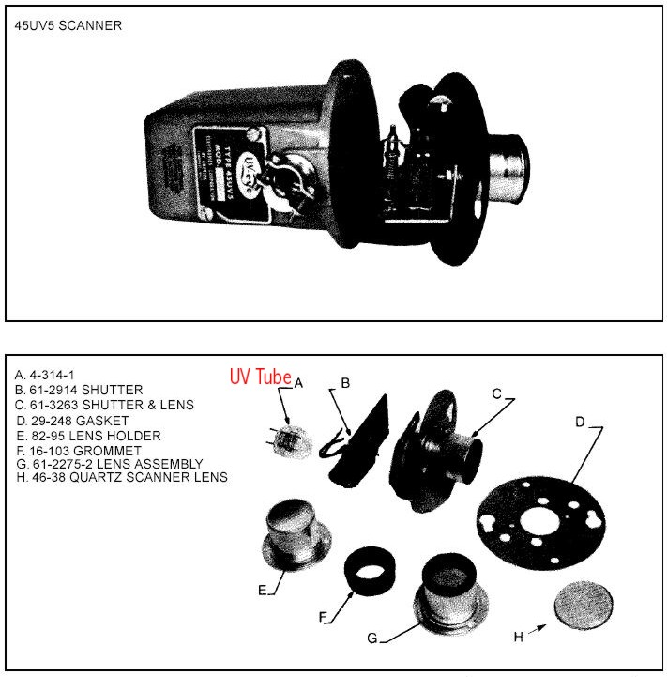

APPLICATION
Fireye 45UV5 self-checking scanners are used to detect ultraviolet emissions from fossil fuel flames such as natural gas, coke oven gas, propane, methane, butane, kerosene, light petroleum distillates and diesel fuels.

These 45UV5 models are used only with the Flame-Monitor, D-Series, FlameWorx, MicroM and some P-Series Fireye control models to provide flame safeguard and monitoring systems for supervised manual, semi-automatic and fully automatic single burner boilers, process ovens and heaters.

UV scanners are recommended for detecting flames from standard fuel gases, some waste gases and light oil fuels such as No. 2 oil. Flames from heavier oils can be detected with UV scanners but the unburned fuel shroud and/or atomization shroud can block passage of the UV from the flame zone to the UV tube, causing nuisance burner/boiler trips. Infrared detection is recommended for fuel oil heavier than No. 2, and some installations where waste gases are burned together with natural gas as a main flame.

Note: Certain safety codes and regulations require the use of self-checking ultraviolet scanners.

Self-checking UV scanners are used in applications where continuous operation of a boiler is preferred. Boilers used to heat oil to be used as a catalyst for chemical process is an example. Non self-checking scanners can only be used on burners/boilers that cycle often. The safety checking circuit needs to be tested during downtime.

PRINCIPLES OF OPERATION
The 45UV5 scanners use a quartz UV-eye detector. This detector is a sealed, gas filled, UV-sensitive tube containing two electrodes connected to a source of AC voltage. When UV radiation of sufficient energy falls upon the electrodes, electrons are released and the inter-electrode gas becomes conductive, resulting in an electric current flow from one electrode to the other. The current flow starts and ends abruptly and is known as an “avalanche.”

A very intense source of UV radiation will produce several hundred avalanches or pulses per second. With less radiation there will be fewer pulses per second. Upon total disappearance of flame, the detector output ceases and the gas acts as an insulator between the two electrodes. Thus, the presence or absence of pulses is an indication of the presence or absence of flame; the frequency of the pulses is a measure of flame intensity. Pulses generated by the scanner are transmitted to a compatible Fireye control via scanner wiring.

FEATURES
The components are contained in a cast aluminum housing sealed with an oil-resistant gasket. The quartz lens is a planoconvex design, resulting in increased sensitivity. This allows for the scanner to be placed at an increased distance from the flame while still retaining accuracy. Also included in the scanner is an electromagnetic shutter that permits a self-checking circuit to verify that the scanner and signal circuits are producing valid flame presence or absence information. During the shutter closed period, the detector’s optical path is blocked from flame radiation, allowing the amplifier control to verify the proper operation of the ultraviolet tube. While the shutter is open, flame presence or absence is detected. The resultant scanner output (while flame is detected) is a continuous, periodically interrupted, pulsed flame signal which is a prerequisite for energizing the associated Fireye control’s Flame Relay.

SPECIFICATIONS
For more details visit: http://www.fireye.com/Tech+Doc+Flame+Scanners+-+CD.shtml

Housing Material:
Cast aluminum
Weight:
7 lbs. (3.2 kg)
Optical Range
: 2200 to 2600 angstroms. No response to infrared radiation or visible light.
Optical Field of View:
1 inch per foot (25.4mm/305mm)
Operating Range:
72 inches (1830mm) or less.
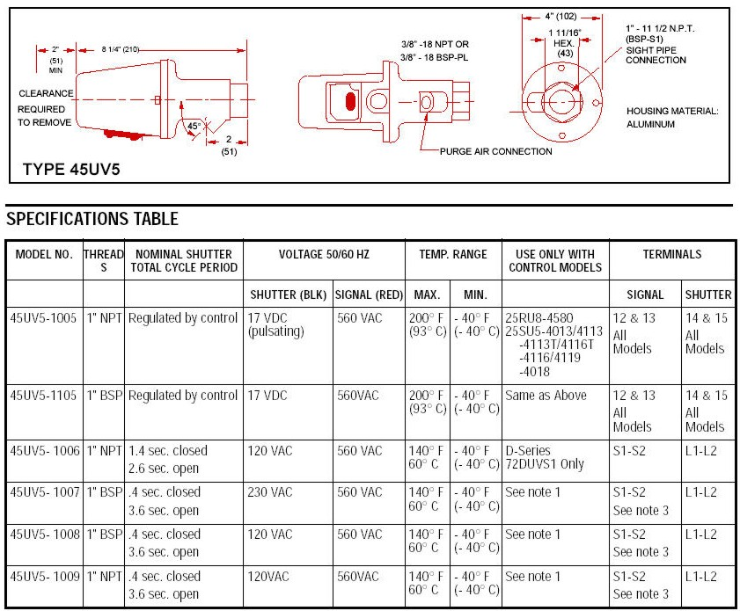

The UV self-checking scanner is a fail-safe device.
— The two red leads to the tube from the control should be approximately 560 VAC.
— The two black leads from the control to the shutter should be a pulsating 16-24 volt signal for the 45UV5-1005 and 45UV5-1105 or line voltage for other 45UV5 models. There are two failure modes of the UV self-check scanner.
1. UV tube failure
2. Shutter failure
Either of these failures will prevent the burner from operating.

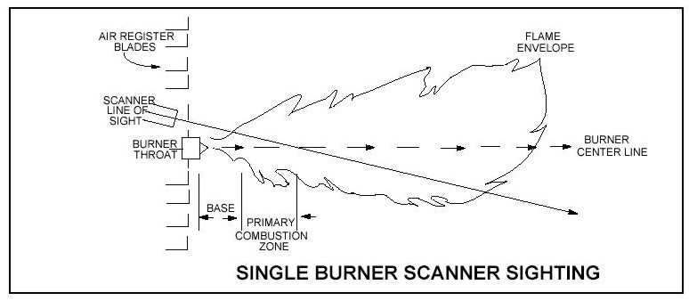
AN ACCEPTABLE SCANNER LOCATION MUST ENSURE THE FOLLOWING:
— Reliable pilot flame detection.
— Reliable main flame detection.
— Rejection of pilot flame too short or in the wrong position to ignite the main flame reliably,
thus prohibiting main fuel admission.
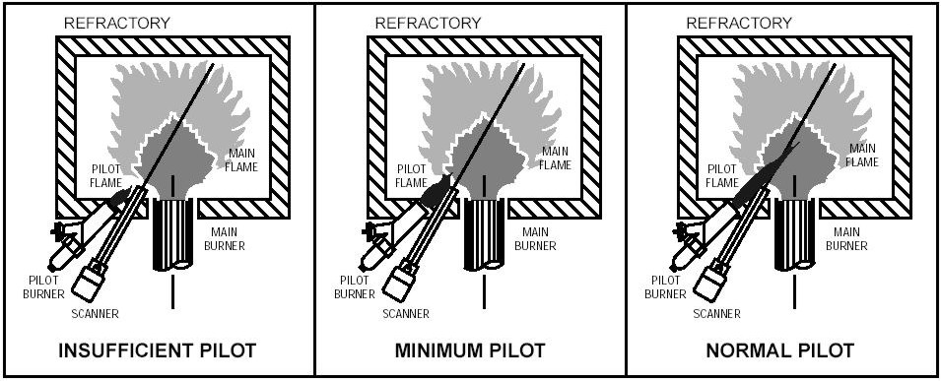

When only one scanner is used per burner, the intersection should be made so the line of sight or viewing angle can also see the pilot flame.

